Time Complexity
 | Worst | Average | Best
Insertion Sort | O(n^2) | O(n^2) | O(n)
Merge Sort | O(n logn) | O(n logn) | O(n logn)
Quick Sort | O(n^2) (unlikely) | O(n logn) | O(n logn)
Shell Sort
Counting Sort
Bucket Sort
Radix Sort

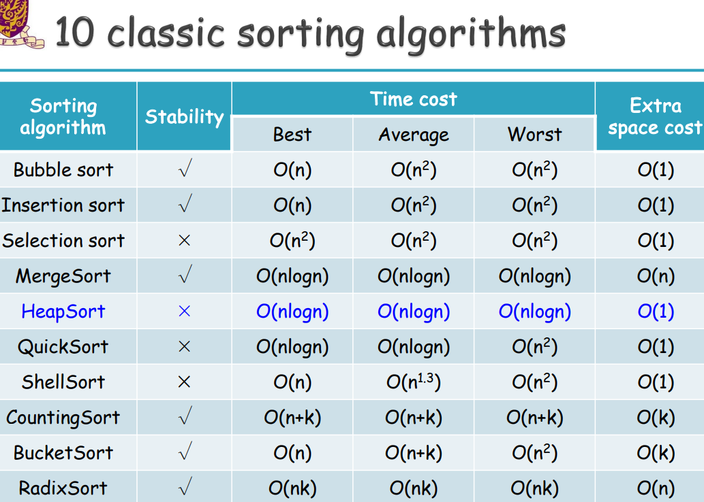

L3 arrays
Pro & Con of arrays:
Pro: If you know the index (where), you can find the object (content) with one basic operation (efficient); Efficient search if array is sorted
Con: The capacity is fixed, so if you insert an object in a place between two objects in an array, you have to move the objects first

Consecutive locations: 数组是一种线性数据结构，它托管存储在计算机内存中连续位置(Consecutive locations)的数据元素的集合

ADT: Abstract Data Type

Array ADT:
createArray(n)
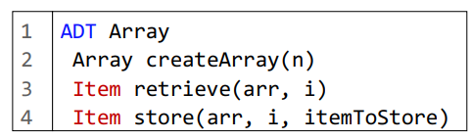
Initialize an array of size n
retrieve(arr, i)
arr[i]
Return the item stored in the i-th position of the array
store(arr, i, itemToStore)
Store itemToStore to the i-th position of the array
arr[i] = itemToStore

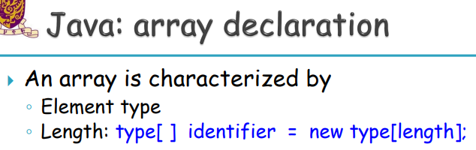
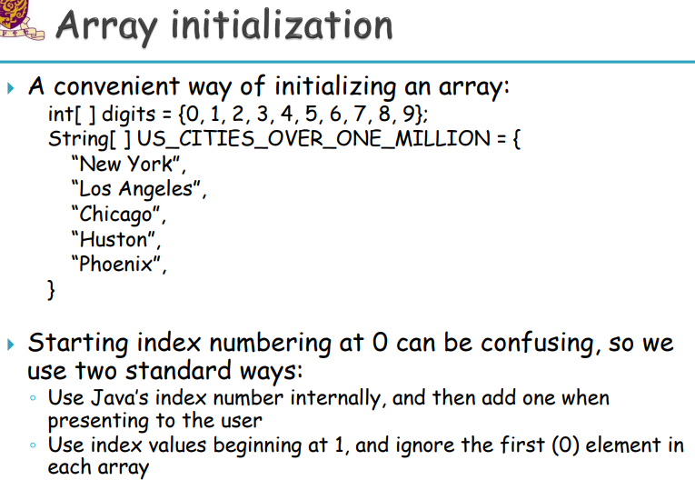
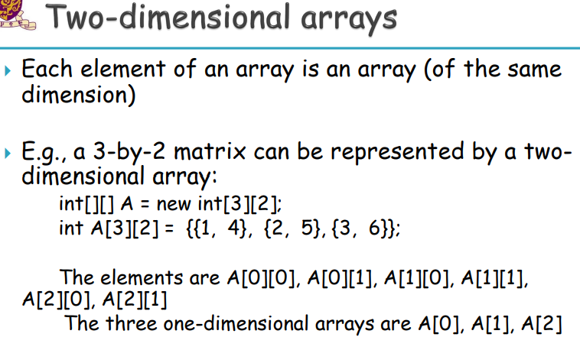
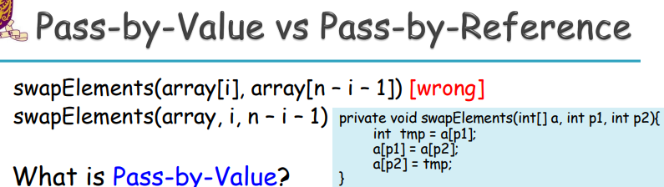

L4 insertion sort and merge sort

(Use array to solve the sorting problem)

Insertion sort
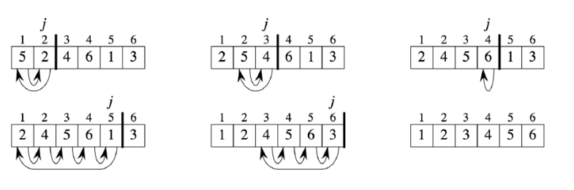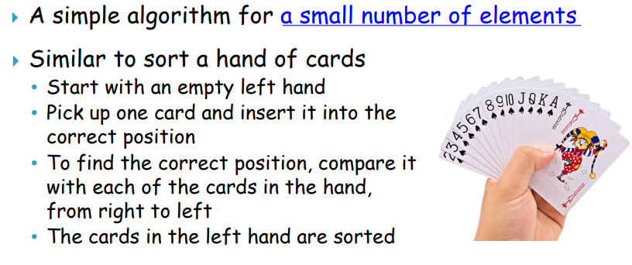
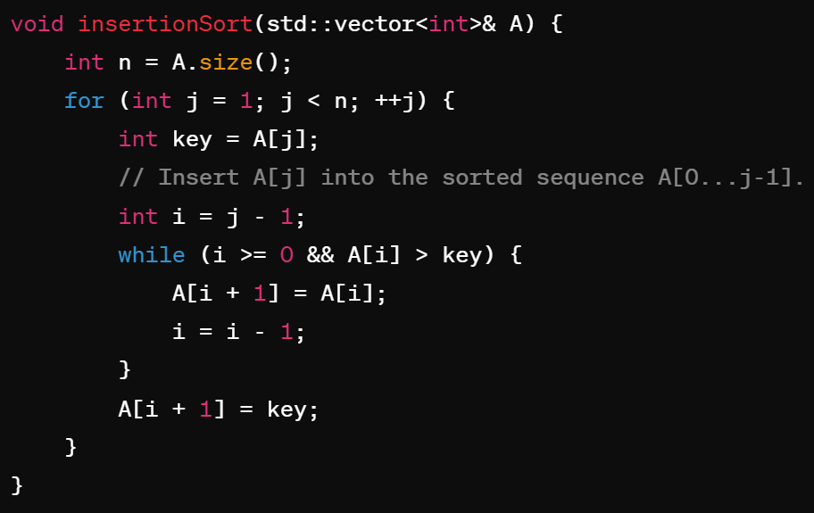

the correctness of the algorithm
Initialization: true before the begin of loop
Maintenance: if true before an iteration, then also true after it
Termination: when the loop stops, use the invariant to show the algorithm is correct

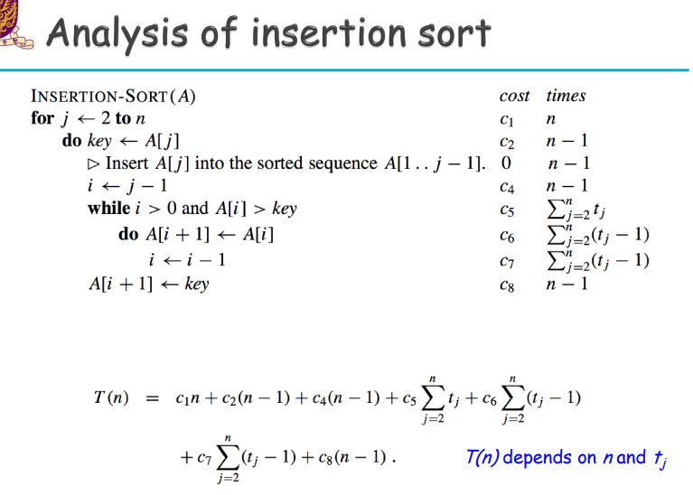
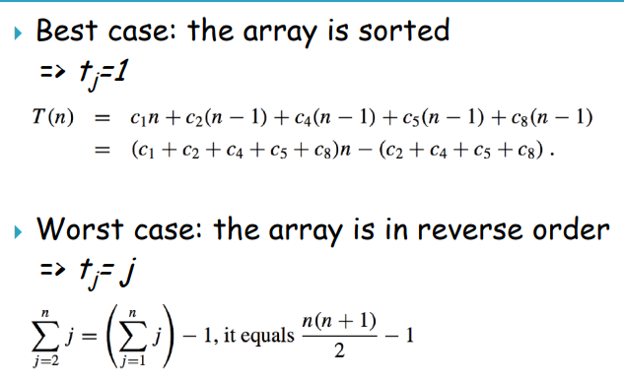
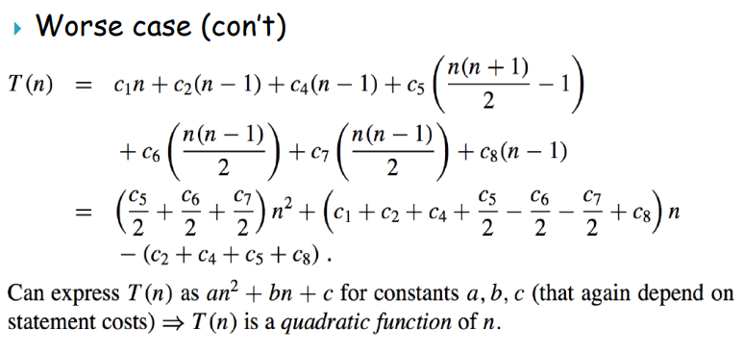

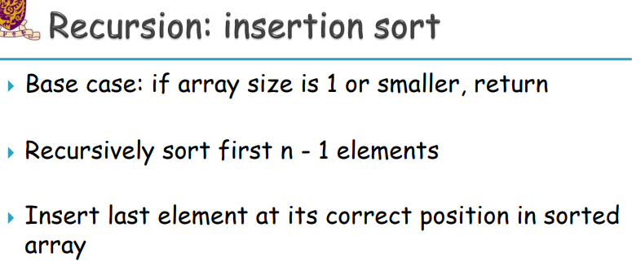

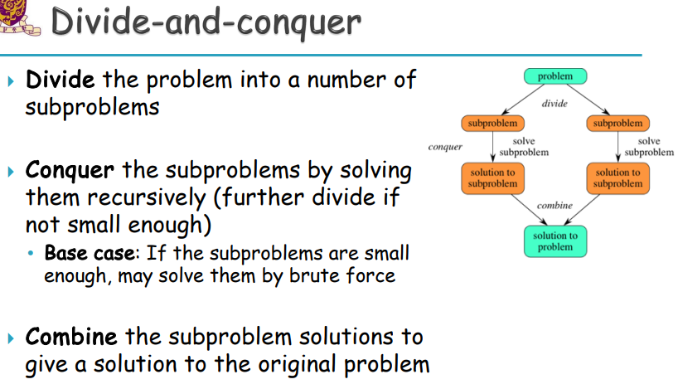

Merge sort

based on divide-and-conquer

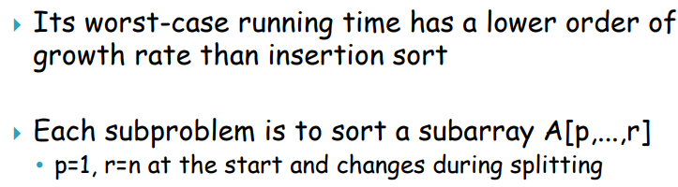
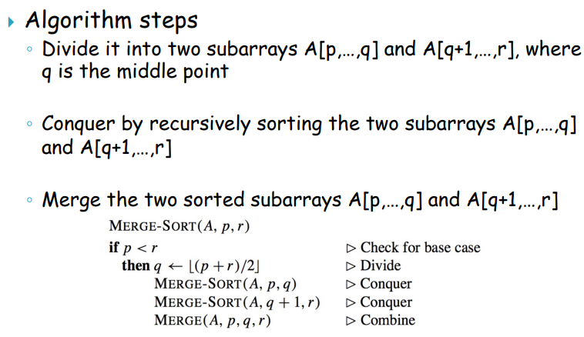
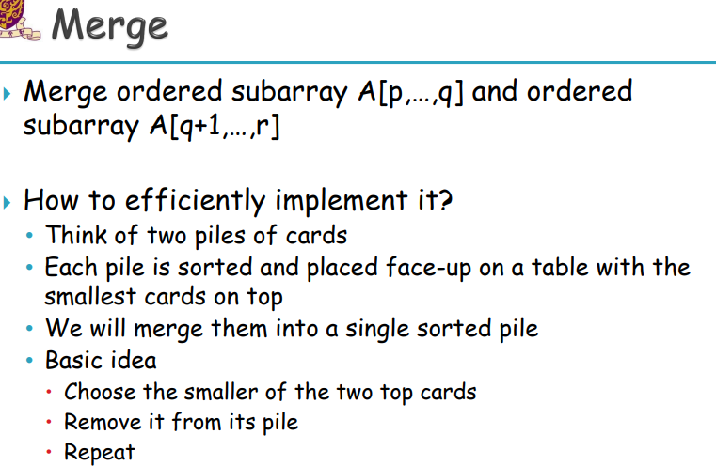
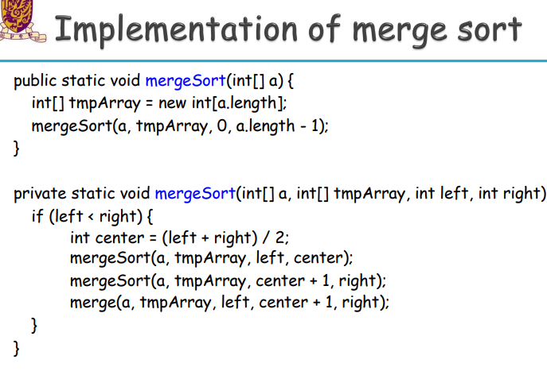
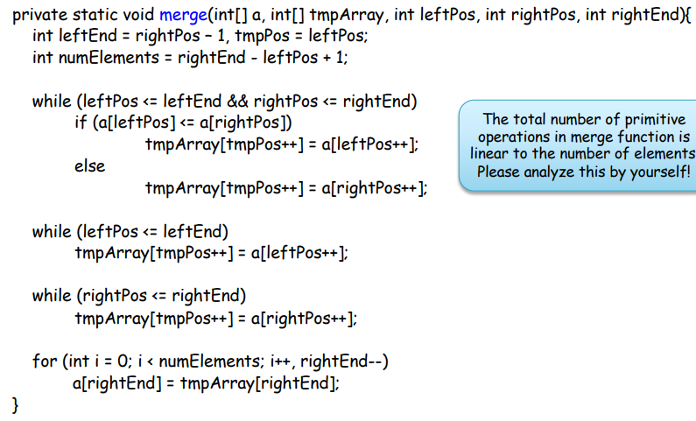
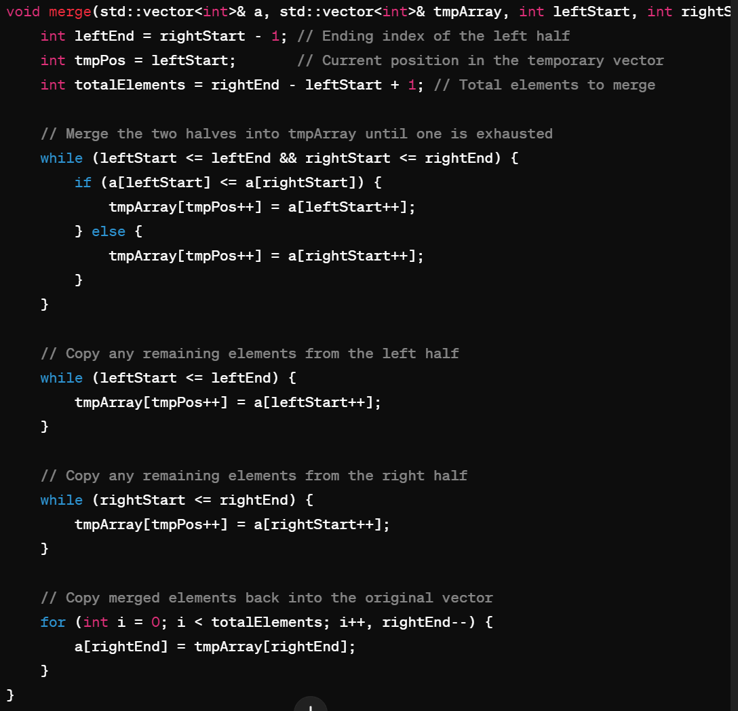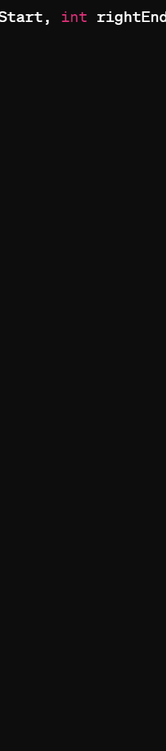

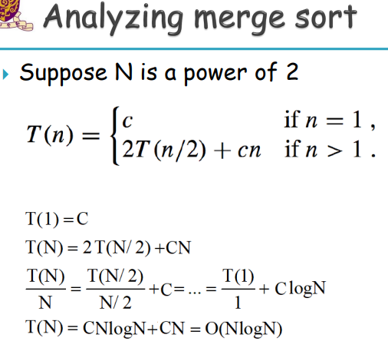
（？？C log(N) ??）
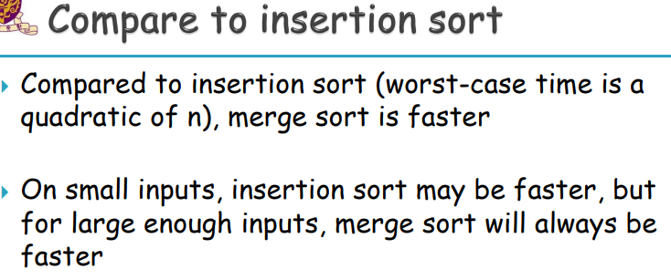
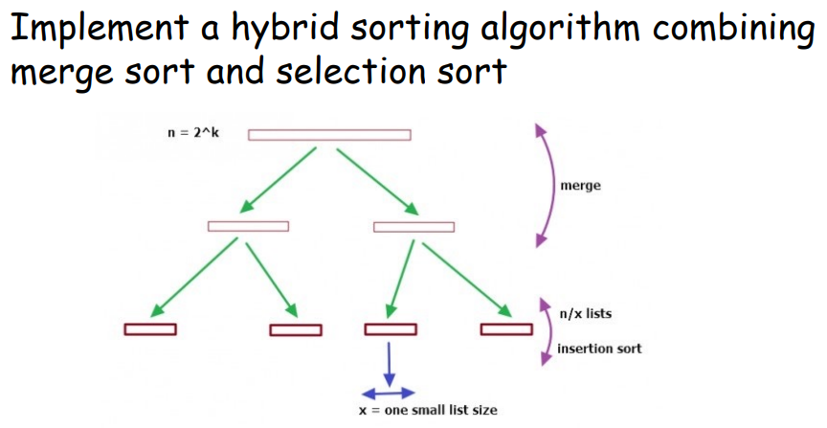

L5 asymptotic notations

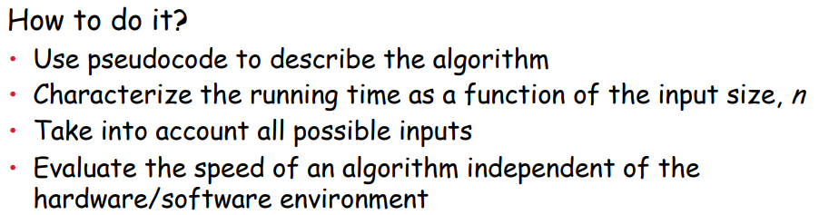

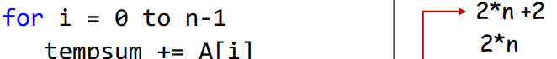
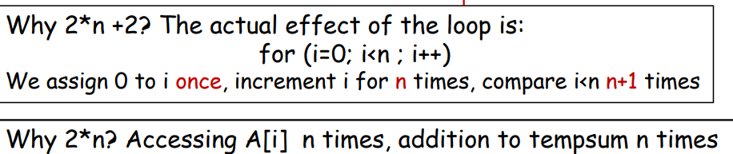

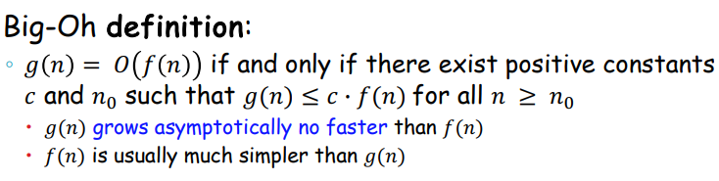
两个意义
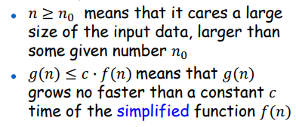
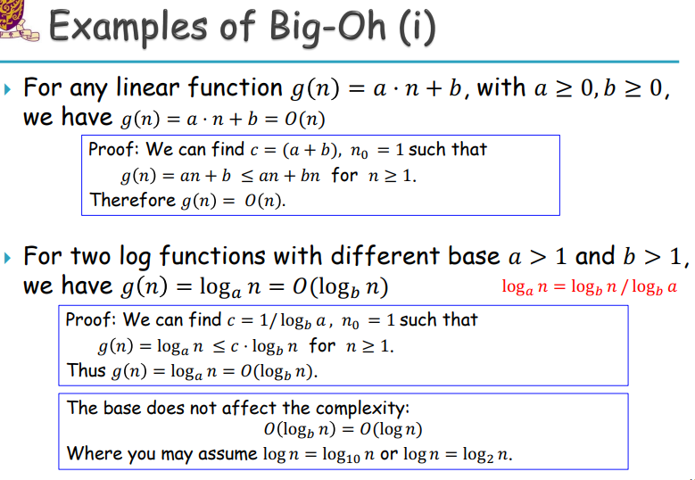
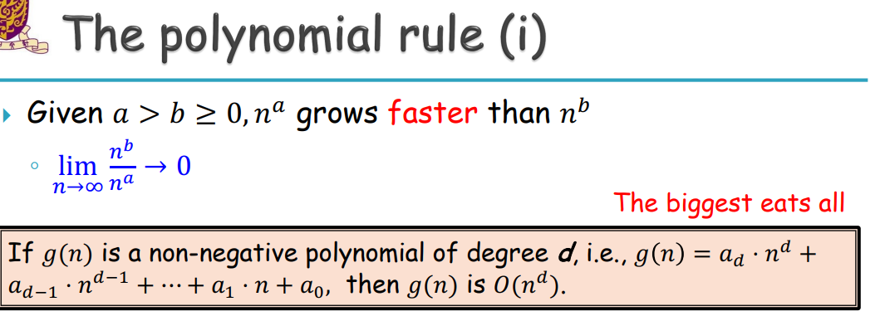
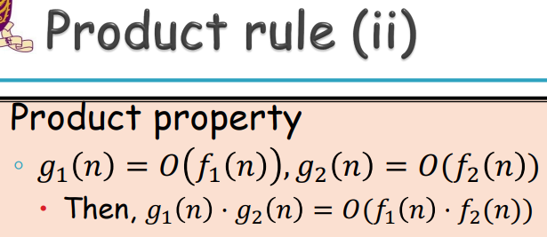
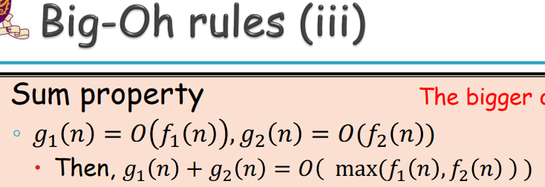
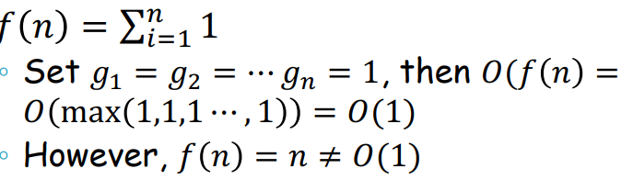
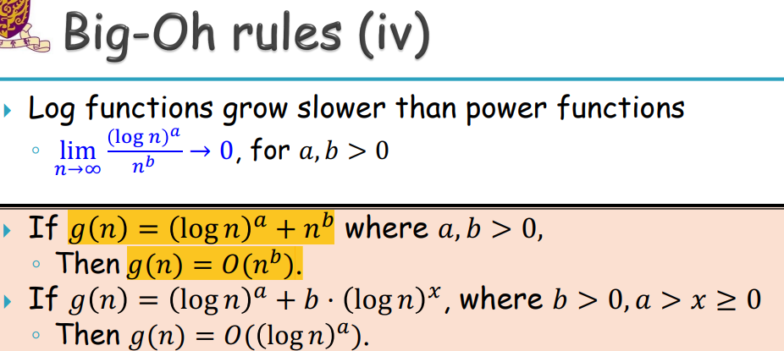
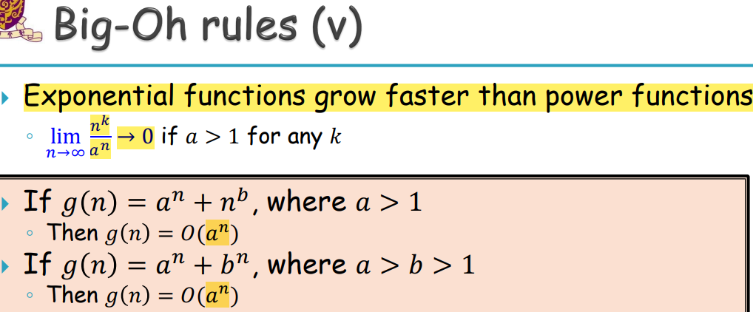
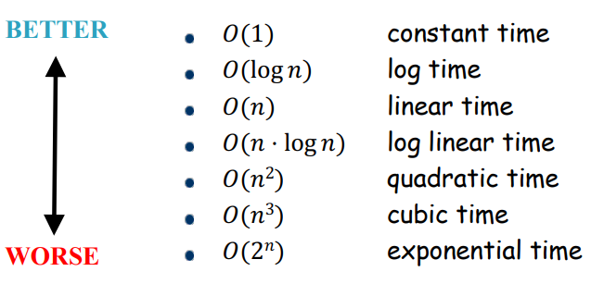
(???) 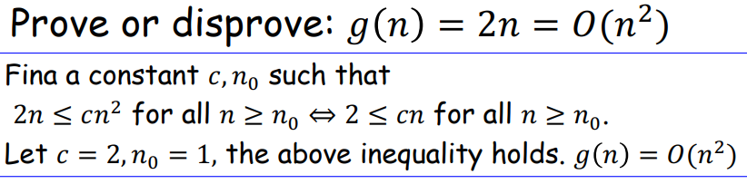

Big-Omega (notation)
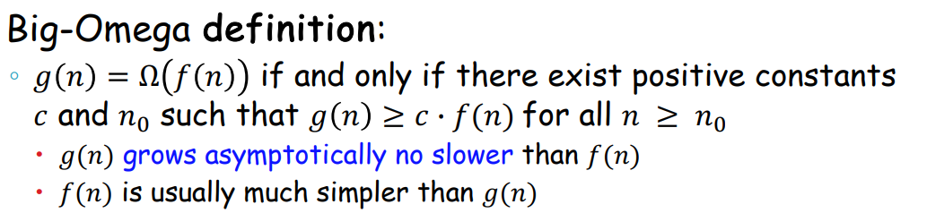
(c·f(n) grows slower than g(n))

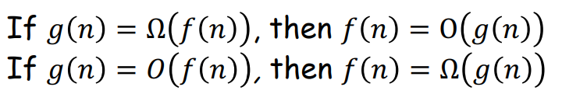
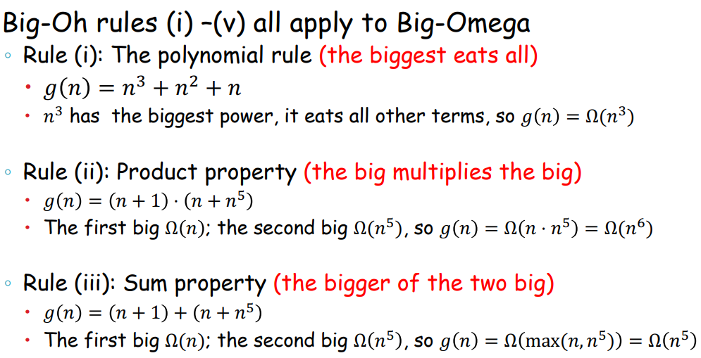
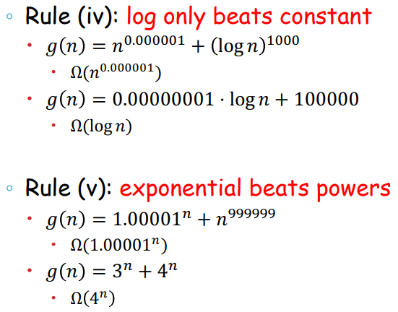

Big-Theta
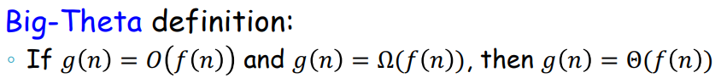

L11 Quick Sort

Quick Sort
Deterministic algorithms (previously other sorting algorithms)
Randomized algorithms
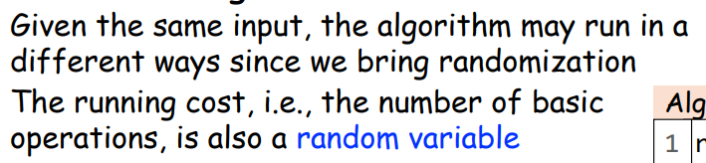

L12

……

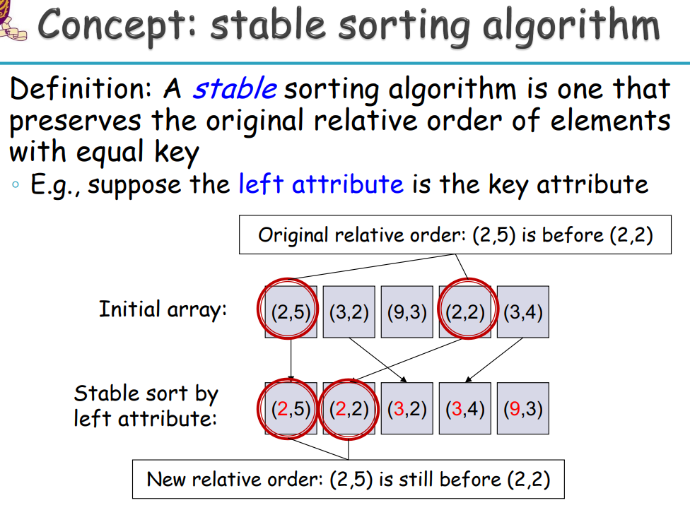

L14

